What Is Infrared Thermography?
Infrared Thermography is the process of using an instrument and a method to detect infrared energies emitted from an object, convert these emitted energies to temperature values, and display an image of the object showing the temperature distribution. To be accurate, the instrument is an Infrared Thermograph and the method is Infrared Thermography. However, the current trend is to incorporate both instrument and method in the term Infrared Thermography.
Characteristics of Infrared Thermography Instrumentation
- Captures a surface temperature distribution and displays it as visible information.
- Temperature is measured from a distance without contacting the measured object.
- Temperature is measured in real time.
Merits of Infrared Thermography Instrumentation
- Relative comparison of surface temperature distribution is made over a wide area.
- Allows temperature measurements of hazardous objects from a safe distance.
- Measures temperature of small objects without interference.
- Temperature of food, medicine or chemicals can be measured in a sanitary fashion.
- Temperature of an object with dynamic temperature changes can be measured.
FAQ’s about Infrared Thermography Instrumentation
- Isn't the infrared camera emitting something? No, it is not emitting anything. It merely detects infrared energy emitted from an object in a passive manner. It should not benoted that the energy detected may be affected byreflected energy from surroundings.
- Isn't the temperature measured by the wave length? No, temperature distribution is measured by the amount of infrared energy.
- Can you see through objects using Infrared Instruments?No. Infrared energy is emitted from the surface of an object; you cannot see through an object. However, it may be possible to estimate the rear side temperature if the temperature distribution appearing on the front surface is due to thermal conductivity from a temperature difference.
What is Infrared Thermography?
- Infrared was discovered by a British astronomer, Herschel, in 1800. When dispersing sunlight using a prism, Herschel accidentally found that there was an invisible energy just beyond the red color wavelength that increases with temperature.
- Infrared is an electromagnetic wave.
- Infrared wavelength is 0.7µm or longer. For a wavelength of 1mm (1000µm) or less the frequency is 300GHz or greater.
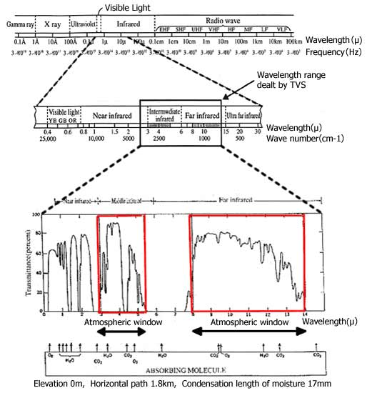

Characteristics of Infrared
- It is invisible since its wavelength is longer than visible light. It has nothing to do with brightness or darkness of visible light.
- It is emitted naturally from any object of which temperature is absolute zero (0K, Zero Kelvin) or higher. Therefore, it can be applied to any field.
- It has a characteristic of heating an object. Therefore, it is sometimes called “heat wave”.
- Because it is a kind of light (electromagnetic wave) it is transmitted through a vacuum.
- There is a correlation between infrared energy and temperature of an object. Therefore, it can be used to measure the temperature of an object.
How the Heat Transfers
- Emission: Heat transfer where the heat is transferred directly from the surface of an object as an infrared energy.
- Convection: Heat transfer to a gas or liquid heated as it passes an object.
- Conduction: Heat transfer mainly through a solid object.
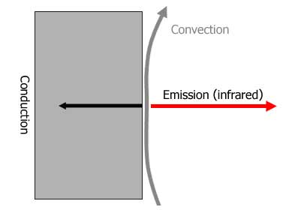

Emission, Reflection and Transmission of Infrared
An object which absorbs infrared well emits infrared well.

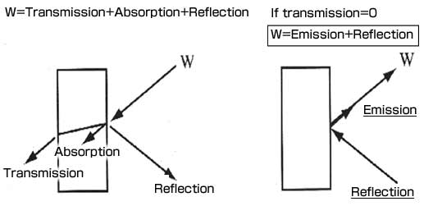

Principle of Measurement by Infrared Thermography Instrumentation
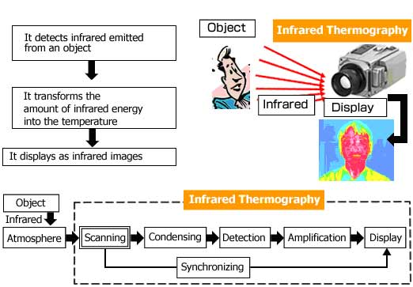

Image Format of Infrared Thermography
- Layout of detector and image data.
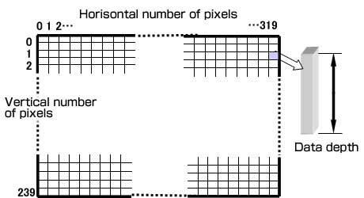

- Temperature distribution image data

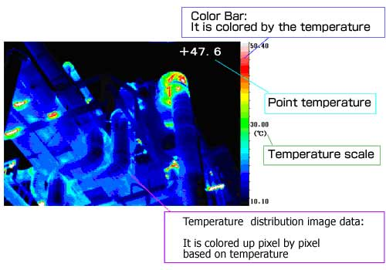
Infrared Thermography instruments display temperature distribution image data using a matrix of pixels (each pixel being a miniature infrared energy detector). In the figure above, there are 320 horizontal x 240 vertical pixels (detectors).
Thermal image data from each of these pixels/detectors may be stored in the Thermography instrument or transferred to a PC for further analysis. The displayed Thermal image is colored pixel by pixel to show the temperature distribution values converted from the detected infrared thermal energy.

